Project Development Phase
Performance Test

Date | 28 September 2026
Team ID | 6ab221341
Project Name | Implement Client Scripts & UI Policy (Incident)
Maximum Marks

Model Performance Testing:
Project team shall fill the following information in model performance testing template.
S.No. | Parameter | Screenshot / Values
- 1 | Client Script Response | Client Script validates incident input and responds correctly.  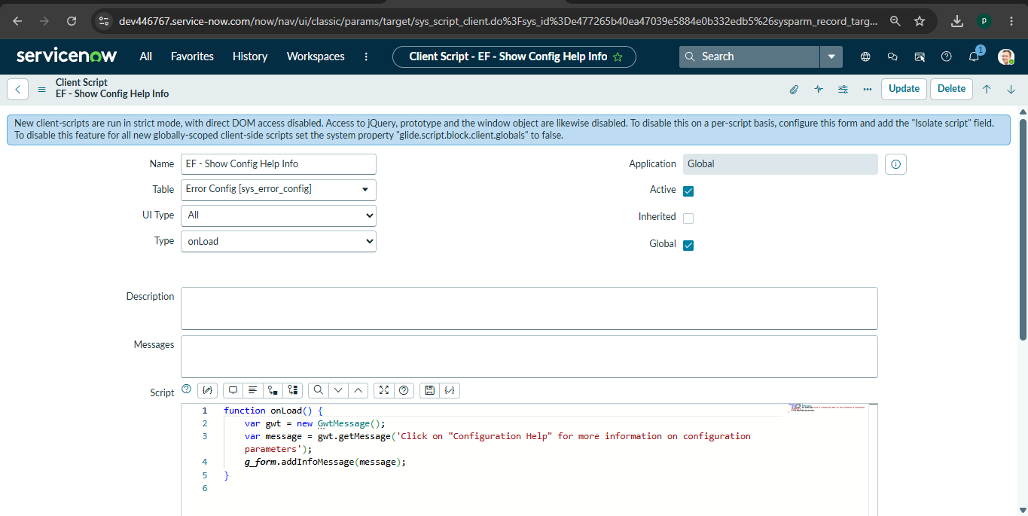
- 2 | UI Policy Response | UI Policy updates field visibility, mandatory and read-only status correctly.  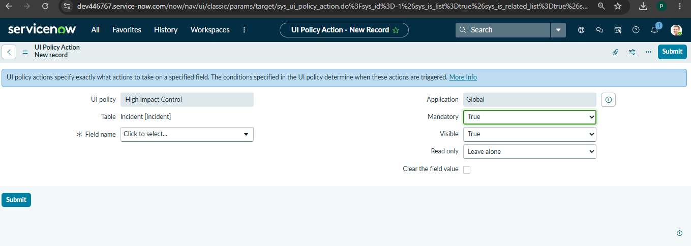
3 | Incident Form Performance | Incident form loads and responds to field changes without noticeable delay.  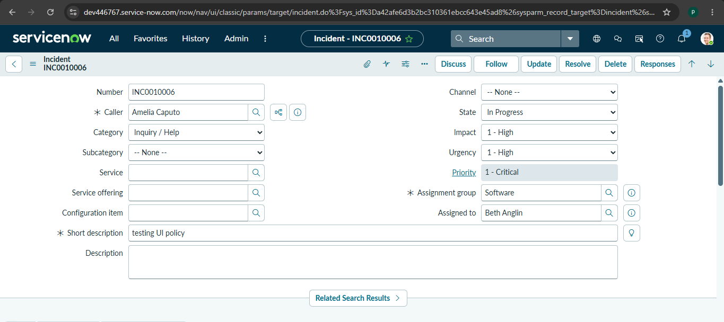
4 | Validation Response | Validation message is displayed promptly for invalid or incomplete input.  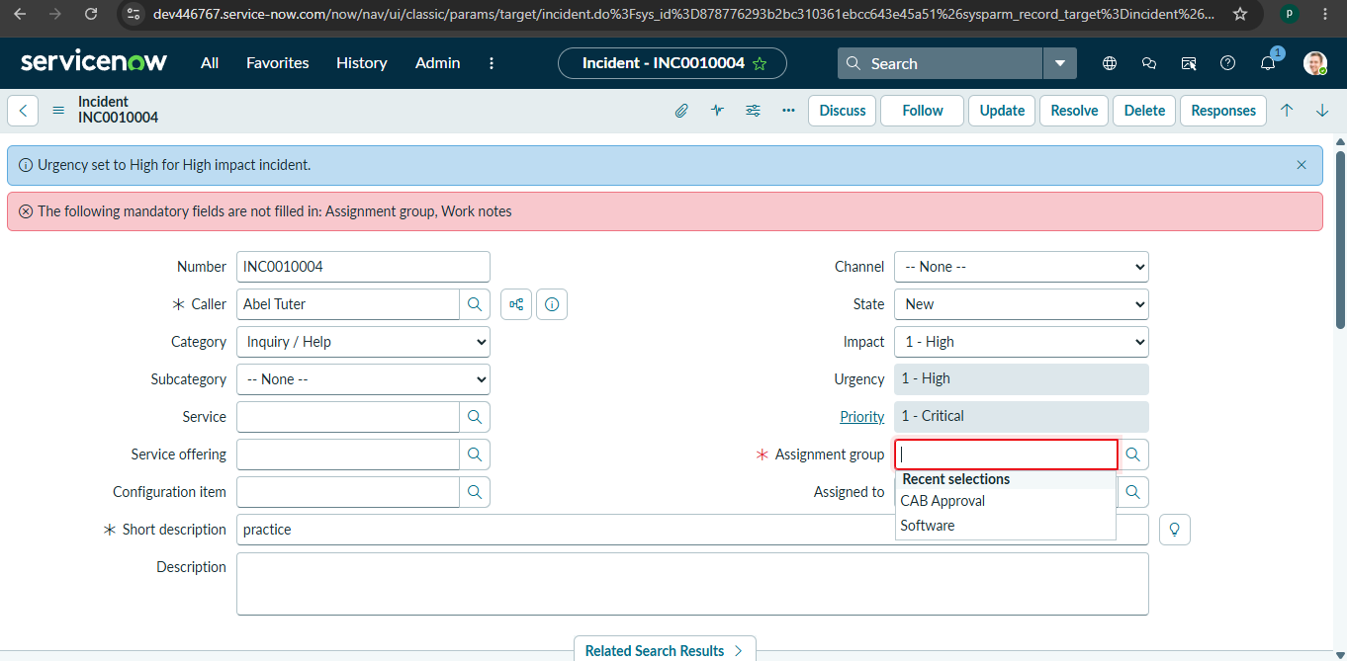
5 | Dynamic Field Behaviour | Incident fields update correctly when configured conditions are triggered.
6 | Incident Submission Performance | Valid incident details are submitted and saved successfully in the ServiceNow Incident Table.

